Student worksheet

1.1 Scientists review the research of other scientists
Pages 2–3

Scientific research
1 Which scientist is called the ‘father of genetics’?
2 What is the term used today to describe Mendel’s ‘factors’?
3 Name the two important principles Mendel identified that form the basis of genetics today.
4 If you inherit your curly hair from your father, does this mean you will also inherit your father’s blue eyes? Give a reason for your answer.
5 Explain how Mendel proved that factors are NOT blended together, as was previously thought.

6 Watson and Crick described the structure of DNA as a double helix. What does this mean?
7 Match the scientists with the correct contribution they gave to genetics.
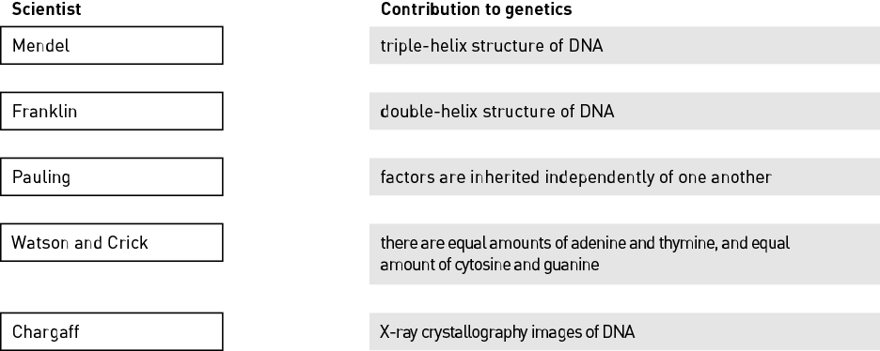

Extend your understanding
8 Explain why it is important for scientists to collaborate and share their research.

Student worksheet

1.2 DNA consists of a sugar-phosphate backbone and four complementary nitrogen bases
Pages 4–5

The composition of DNA
1 Name the chemical that all genes are made up of.
2 Name the four complementary nitrogen bases.
3 Identify the type of cell that contains no DNA.
4 Label the three components of the nucleotide shown below.
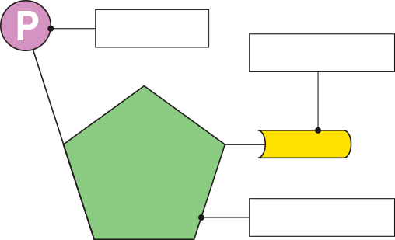
5 Fill in the blanks.
The bases adenine and thymine are joined by hydrogen bonds, while cytosine and guanine are joined by hydrogen bonds.
6 Describe the two vital roles of a DNA molecule.
7 A strand of DNA has the base sequence AATGCGATGC. Give the base sequence for the complementary strand.

Extend your understanding
Nitrogen bases always exist as complementary base pairs within a DNA molecule. Adenine is always paired with thymine, while cytosine is always paired with guanine.
8 Consider a particular gene with a total of 100 bases. If 24 of these bases are adenine, how many thymine, cytosine and guanine bases would there be?
9 By studying the structure of DNA, more knowledge is gained to assist us in other areas of science; for example, in the treatment of medical disorders such as diabetes. Suggest three other areas of science that may benefit from studying the structure of DNA.

Student worksheet

1.3 Chromosomes are DNA molecules carrying genetic information in the form of genes
Pages 6–9

Chromosomes
1 Order the following terms from smallest to largest.
Gene Chromosome Nucleotide Phosphate
2 Circle the sex chromosomes shown in in the human karyotype below.
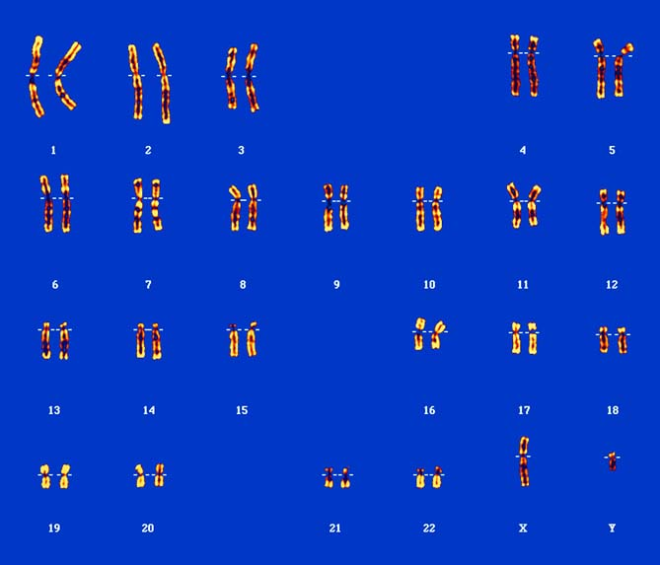
3 Is the karyotype above for a male or a female? How can you tell?

4 If unravelled, the DNA of a single cell would be approximately 2 metres long. Explain how it fits inside a cell.
5 A gene is a section of DNA. Explain what makes one gene different from any other gene within a DNA strand.
6 Fill in the blanks.
Proteins are made up of smaller subunits called that are joined together by bonds during the process of .
7 Name the two processes shown in the diagram below.
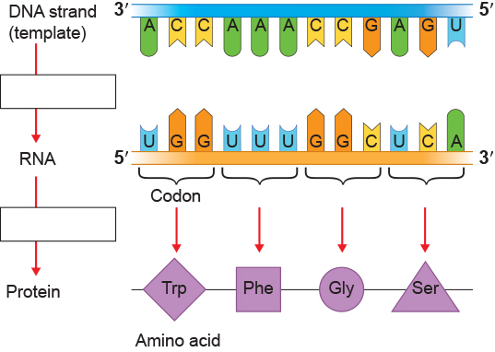
8 Complete the Venn diagram to compare the similarities and differences between DNA and RNA. Do this by placing each key word from the list in the correct position on the diagram. The first key word has been completed for you.
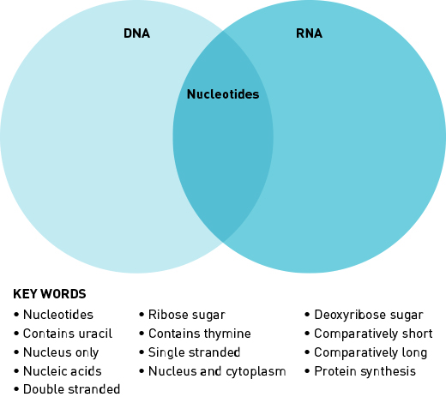
9 Transcribe the following DNA template sequence into an RNA sequence.
DNA template: GAT ACC GCA TTC
RNA sequence: __________________

Extend your understanding
Our bodies are made up of proteins, which consist of different combinations of 20 amino acids that are joined together during translation.
10 Use the internet to research the sources of these 20 amino acids that are used within our cells during protein synthesis.

Student worksheet

1.4 Mitosis forms new somatic cells
Pages 10–11

Mitosis
1 Match each term with the correct definition.
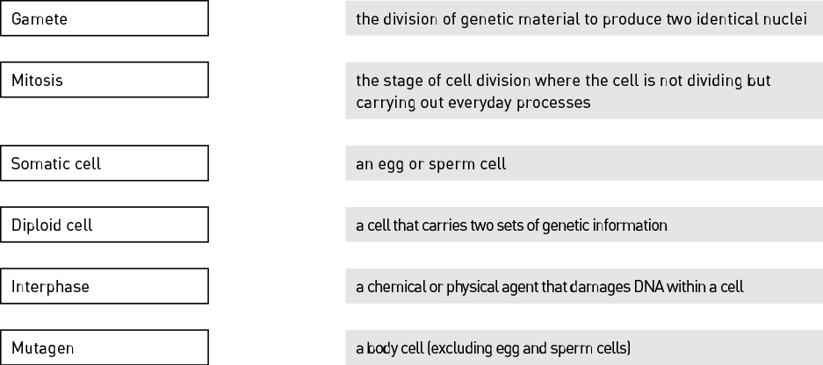
2 Identify the stage of mitosis shown in the following image.
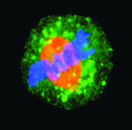
3 Describe what occurs during this stage of mitosis.

4 Why do somatic cells need to undergo mitosis?
5 Identify three ways a cell’s DNA can become damaged:
6 Explain why a cell undergoes apoptosis.
7 Fill in the blanks.
The processes of and together produce two new, genetically identical daughter cells.
8 Explain why a cancerous cell continues to carry out mitosis rather than being destroyed by apoptosis.

9 Label the stages of mitosis shown in the image below.

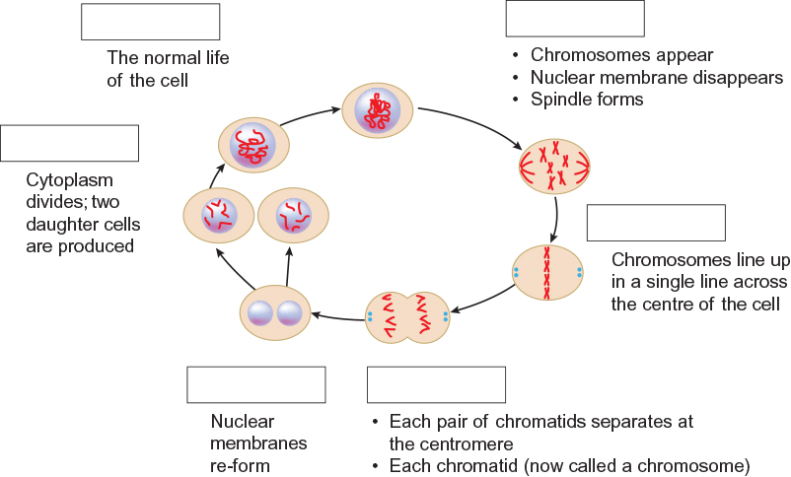

Extend your understanding
10 Identify the cell types that undergo mitosis by writing ‘yes’ or ‘no’ in the table.
Cell type | Mitosis? (yes or no)
Bone cell
Egg cell
Intestinal cell
Nerve cell
Sperm cell
11 Explain why only some of the cells listed in the table above undergo mitosis.

Student worksheet

1.5 Meiosis forms gamete cells
Pages 12–13

Meiosis
1 What is a gamete cell?
2 Fill in the blanks.
The process of meiosis produces , which fuse during the process of
to produce a , the first diploid cell of a new organism.
3 How many stages are in the process of meiosis and what are they called?
4 What happens to the number of chromosomes in meiosis?
5 Complete the table below by determining which type of cell division (mitosis or meiosis) occurs in each cell type.
Cell type | Type of cell division
Bone cell
Ovum
Guard cell
Skin cell
Sperm cell

6 If a goldfish’s intestinal cells each contain 94 chromosomes, how many would be present in the goldfish eggs produced by a female goldfish? Explain your answer.

7 What does the ‘n’ and ‘2n’ represent in the diagram shown?
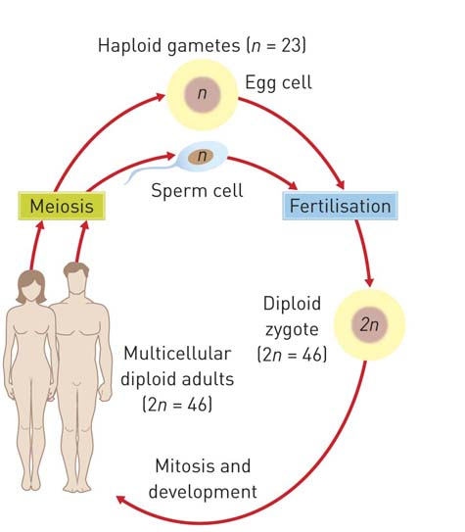

8 Outline how four gamete cells form from a single diploid cell during the process of meiosis I and meiosis II.

Extend your understanding
9 Suggest why meiosis is also referred to as reduction division.

Student worksheet

1.6 Alleles can produce dominant or recessive traits
Pages 14–15

Alleles
1 What is an allele?
2 Describe the difference between the terms genotype and phenotype.
3 The diagram below is of a pair of chromosomes and shows the alleles for hair colour.
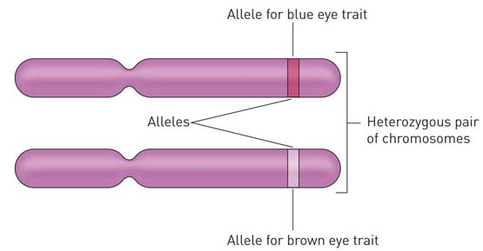
For eye colour (B) of this individual, determine
a genotype: __________________
b phenotype: __________________

4 Write definitions for the following terms.
Term | Definition
Gene
Loci
Chromosome
Carrier
5 Attached earlobes (E) is dominant to unattached earlobes. Write down the possible genotypes of
a attached earlobes: __________________
b unattached earlobes: __________________
c carriers: __________________
6 Long eyelashes (L) is dominant to short eyelashes. A woman and man, both with long eyelashes, have two children. The daughter has long eyelashes and the son has short eyelashes. Write the possible genotypes for each parent and child.
a Mother: __________________
b Father: __________________
c Daughter: __________________
d Son: __________________
7 Right-handedness (H) is dominant to left-handedness. A right-handed man and a right-handed woman have two children that are both left-handed. Complete the Punnett square below and indicate how two right-handed parents can have two left-handed children.
Father
Mother

Extend your understanding
8 Short hair is dominant over long hair in guinea pigs. A student has a female guinea pig with short hair. The student wants to purchase a male guinea pig and breed the guinea pigs safely and ethically to produce only short-haired babies.
a What phenotype male guinea pig would the student need to buy?
b Explain why the student could not guarantee that all the babies will also have short hair.

Student worksheet

1.7 Alleles for blood group traits co-dominate
Pages 16–17

Co-dominant traits
1 What is co-dominance?
2 List all the different alleles for ABO blood grouping.
3 Which allele is recessive and which alleles are co-dominant with regards to ABO blood grouping?
4 What is the phenotype for each of the following individual’s genotypes?
a I^{A} I^{B} __________________
b I^{B}i: __________________
c ii: __________________
d I^{B}I^{B}: __________________
5 What percentage of individuals are rhesus negative?
6 Emma has the genotype I^{A}I^{B} and Geoff has the genotype I^{A}i.
a What is Emma’s phenotype? __________________
b What is Geoff’s phenotype? __________________

c Draw a diagram in the space below to show how the surface of Emma’s red blood cells differ to those of Geoff’s.
Emma’s red blood cells: |  | Geoff’s red blood cells:
d Complete the Punnett square below to determine the possible genotypic and phenotypic ratios of Emma and Geoff’s children.
 |  | Geoff
 |  | I^{A} | i
Emma |  | I^{A}I^{A} | I^{A}i
Emma |  | I^{A}I^{B} | I^{B}i

Genotypic ratio:
Phenotypic ratio:

Extend your understanding
7 Explain why it is preferable for a patient to be given the same blood group when receiving a blood transfusion.
8 Explain why it is possible in an emergency for a patient who is AB+ to receive blood from any other blood group, while a patient who is O– can only receive blood from an O– donor. You may need to use the internet to research this topic.

Student worksheet

1.8 Alleles on the sex chromosomes produce sex-linked traits
Pages 18–21

Sex-linked traits
1 What are autosomes?
2 What are sex chromosomes?
3 What sex chromosomes does a human male have?
4 Does a human male’s Y chromosomes come from his mother or his father? Why?
5 Fill in the blanks.
In humans, the genotype of a female is and the genotype of a male is .
6 Identify which is the X chromosome and which is the Y chromosome in the image below:
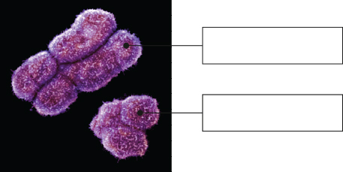
7 Name the term used to describe traits and genes that are carried on the sex chromosomes.
8 Give ONE example of a non-sexual trait that is carried on the human X chromosome.
9 Explain why there is a greater percentage of males than females that have red–green colour blindness.
10 Match the patterns of inheritance with the correct example.
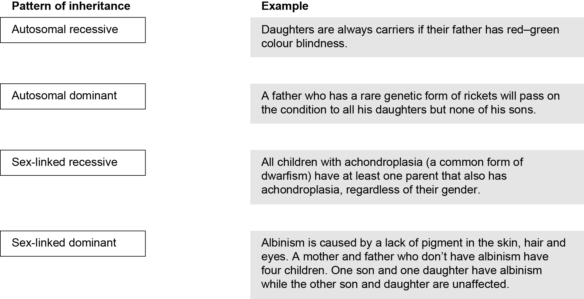
11 Suggest how a man and woman, both with normal sight, could have children that have red–green colour blindness. Include a Punnett square in your answer.

Extend your understanding
12 Suggest why sex-linked traits are more frequently found on the X chromosome than on the Y chromosome, and explain how this affects the inheritance of these traits differently in males and females.
Student worksheet

1.9 Inheritance of traits can be shown on pedigrees
Pages 22–25

Pedigrees
1 What does a pedigree show?
2 Match the following pedigree symbols with the correct meaning.
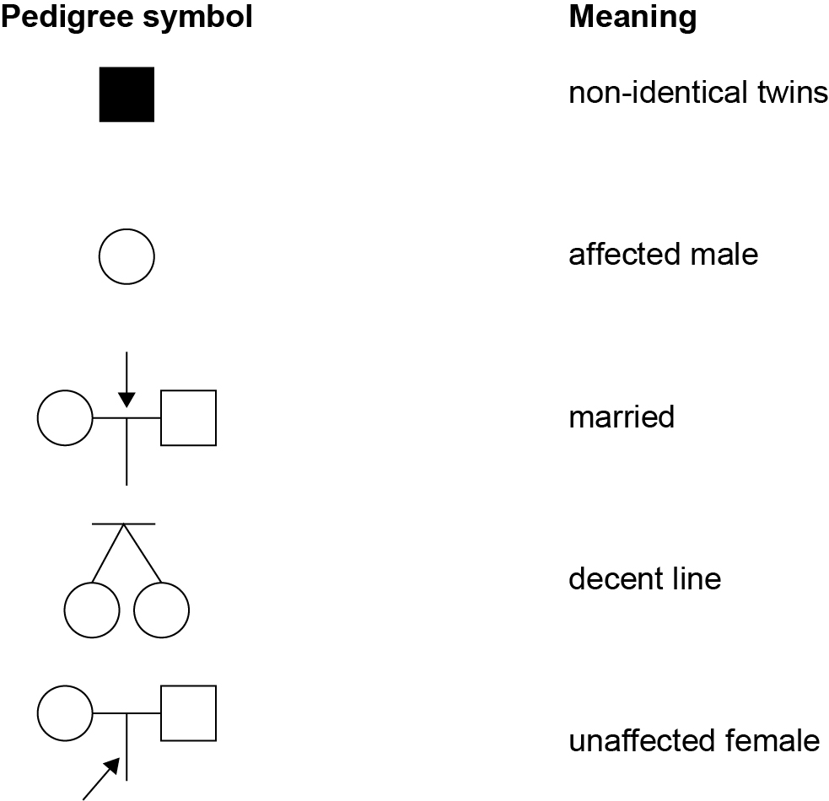
3 What is the symbol in a pedigree for an affected female?
4 What are used to represent different generations in a pedigree?
5 If affected children always have affected parents, what is the pattern of inheritance of the characteristic?

6 The pedigree below shows the inheritance of haemophilia, a sex-linked recessive disease that prevents blood from clotting.
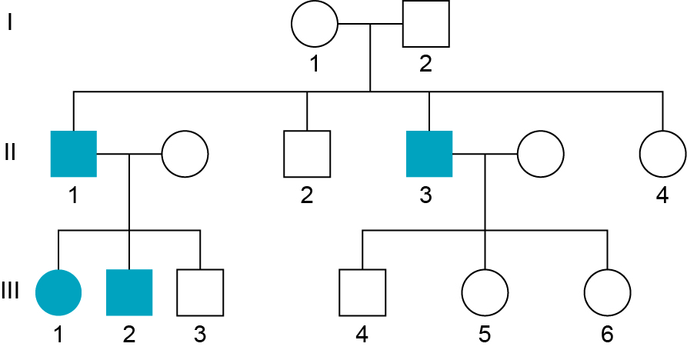
a Use appropriate symbols to write the genotype of individuals I1 and I2 from the pedigree.
Individual I1: __________________
Individual I2: __________________
b Explain how you determined their genotypes.
7 Analyse the pedigree below to answer the questions that follow.
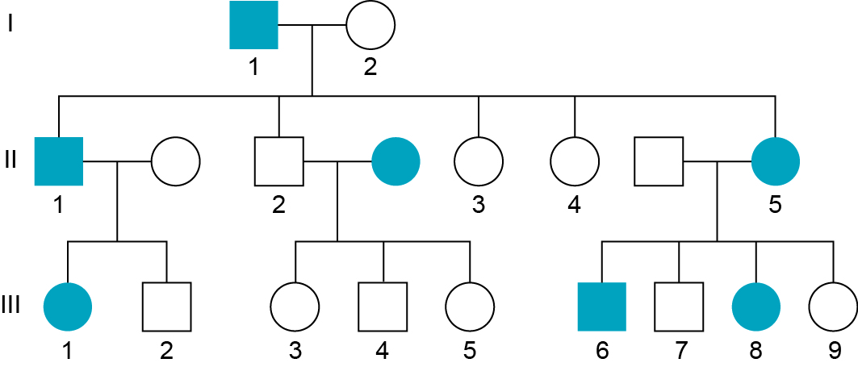
a List the numbers of all the affected males.
b How many children were born in the second generation?

c Determine the pattern of inheritance by analysing the pedigree. Justify your choice.

Extend your understanding
Cystic fibrosis is an inherited disease of the secretory glands, primarily affecting the lungs. It is an autosomal, recessive disease. A couple, both unaffected by cystic fibrosis have three children. The third child has cystic fibrosis.
8 Using appropriate symbols, complete a Punnett square and basic pedigree in the space below to show how two unaffected parents could have one of their three children with cystic fibrosis. Add as much detail as possible to your pedigree.

9 What is the chance of the two unaffected children being carriers?
10 The couple would like to have another child. What are the chances this child will also have cystic fibrosis?

11 The couple would probably benefit from genetic counselling before making the decision to have another child. Using the internet, find out what genetic counselling provides to families with inherited disorders.
Student worksheet

1.10 Mutations are changes in the DNA sequence
Pages 26–29

Mutations
1 Complete the following table by identifying the correct terms and writing definitions in the spaces provided.
Term | Definition
 | A permanent change in the nucleotide sequence of a single gene.
Mutagen
Chromosomal mutation
 | Forms free radicles that cause damage to DNA and proteins.
 | A group of three bases on DNA.
Non-disjunction
2 Use the image below to answer the following questions.
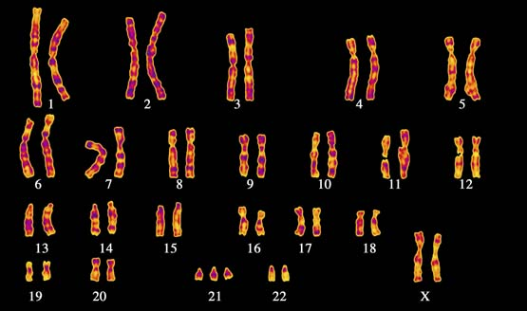
a Which chromosome has had a change in number?
b What syndrome does this person have?
c Is this a chromosomal mutation or a genetic mutation?
d Outline how this type of mutation occurs during meiosis.
3 Use the following nucleotide sequence to answer the questions.
AGG GAT CCG ATA ACC
a Rewrite the nucleotide sequence to demonstrate a mutation where the first thymine is substituted for guanine.
b The sequence change in part a is an example of what type of mutation?
c Rewrite the original nucleotide sequence to demonstrate a mutation where the first thymine is deleted.
d The sequence change in part c is an example of what type of mutation?
4 Suggest why a frameshift mutation has a more damaging affect than a point mutation.
5 Would the allele for blue eye colour have been from a genetic mutation or a chromosomal mutation? Give a reason for your choice.

Extend your understanding
6 Not all mutations are harmful. Use the internet to research beneficial mutations and explain how they can lead to the formation of new alleles. Give an example of a beneficial mutation in your answer.

Student worksheet

1.11 Genes can be tested
Pages 30–31

Genetic screening and testing
1 What are probes?
2 In genetic testing, why is the DNA taken from the white blood cells of a patient’s blood sample?
3 Create a table to show the different genetic screening and testing services currently available in Australia.
Genetic screening and testing | What individuals are screened? | An example of a disease, disorder or defect being screened
4 Identify an ethical implication that genetic screening and testing poses.
5 Explain the benefit of genetic testing to a couple to determine if they are carriers of an inherited family disorder.

Extend your understanding
6 Create a list of questions you would ask a genetic councillor if it were recommended that you are screened for the early detection of a disease.

Student worksheet

1.12 Genes can be manipulated
Pages 32–33

Manipulating genes
1 What key feature of DNA enables it to be transferred from one species to another?
2 Write definitions for the following terms.
Term | Definition
Genetically modified organism
Transgenic organism
Genome
Biodiversity
3 How does introducing a GM crop lead to a decline in biodiversity?
4 Complete the table to summarise the resistance of transgenic cotton and papaya and the advantage it gives them over natural varieties.

 | GM crop | Resistance | Advantage
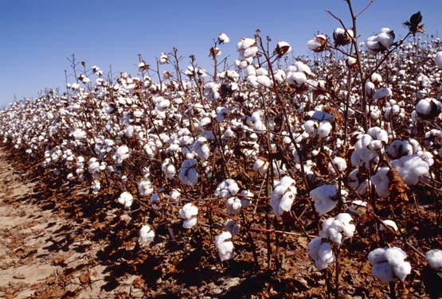 | Cotton
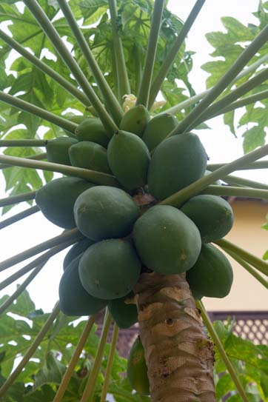 | Papaya

Extend your understanding
Genetically modified soybeans have a drought-resistant gene, which has been isolated from sunflowers, inserted into their genome. Trials have shown these GM crops to have up to 15% greater yield (production) in drought conditions compared with soybeans that have not been modified.
5 Is the soybean plant a genetically modified organism or a transgenic organism? Justify your choice.
6 Identify two advantages to farmers of being able to produce drought-resistance crops such as the soybean crop.
7 Draw a series of labelled diagrams to show how a soybean plant can become drought resistant through genetic modification.

Student worksheet

1.13 Genetic engineering is used in medicine
Pages 34–35

Genetic engineering
1 What are the germ line cells of an organism?
2 Place the following gene-cloning steps in the correct order by labelling the diagrams as 1–5.
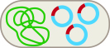

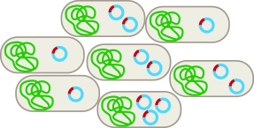
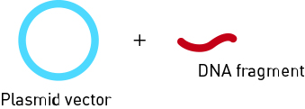
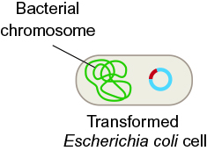

3 When a DNA fragment is incorporated into a plasmid vector, what molecule is formed?
4 Complete the table summarising the applications of gene cloning and gene therapy using the examples of insulin production and cystic fibrosis.
 | Gene cloning | Gene therapy
Example | Insulin production | Cystic fibrosis
Description
Advantages
Disadvantages
5 Stem cells are undifferentiated cells. What does this mean?

6 The use of ‘excess embryos’ is seen to be unethical by some people. Why?
7 Write definitions for the different types of stem cells in the following table.
Type of stem cell | Definition
Pluripotent embryonic
Multipotent adult
Induced pluripotent

Extend your understanding
8 Why would scientists want to turn multipotent adult stems cells back into pluripotent stem cells?

